**Advancements in Privacy-Preserving Cryptographic Technologies for Secure Healthcare Data Management and Sharing**

|  |  |
| --- | --- |
| I.G.K.N.M. Attanayake  Student of Undergraduate Computer Science  Saegis Campus  Nugegoda, Sri Lanka | D.R.D.M. Dodampoththa  Student of Undergraduate Computer Science  Saegis Campus  Nugegoda, Sri Lanka |
|  |  |
| K.U. Sewwandi  Student of Undergraduate Computer Science  Saegis Campus  Nugegoda, Sri Lanka | K.N.N. Wickramanayake  Student of Undergraduate Computer Science  Saegis Campus  Nugegoda, Sri Lanka |

**Abstract**

The rapid adoption of Electronic Health Records (EHRs) and digital health technologies has revolutionized healthcare but also introduced critical challenges in ensuring the privacy and security of sensitive medical data. Cryptographic technologies, including symmetric and asymmetric encryption, homomorphic encryption (HE), and proxy re-encryption (PRE), have emerged as pivotal tools to secure healthcare data during storage and transmission. This paper reviews the advancements in privacy-preserving cryptographic technologies, focusing on their potential to address challenges such as data re-identification, cyber-attacks, interoperability issues, and regulatory compliance. Notable innovations like HE enable secure computations on encrypted data, and blockchain technology offers a decentralized and tamper-proof framework for data sharing among stakeholders. Despite their promise, limitations such as computational complexity, high implementation costs, and interoperability challenges persist. Future research should prioritize quantum-resistant algorithms, scalable HE techniques, and lightweight cryptographic solutions tailored for resource-constrained healthcare environments. Integrating artificial intelligence (AI) with cryptography and fostering global collaboration could further enhance data security, privacy, and efficiency in healthcare systems.

**Keywords:** Healthcare data security, cryptography, homomorphic encryption, proxy re-encryption, blockchain, privacy-preserving technologies, quantum-resistant cryptography, interoperability, Electronic Health Records (EHRs).

**Introduction**

The increasing reliance on Electronic Health Records (EHRs) and other digital health technologies has transformed healthcare by enabling more efficient management and exchange of patient data. However, the widespread adoption of digital healthcare systems has raised concerns regarding the privacy and security of sensitive medical information. Cryptography has emerged as a critical solution to safeguard this data during transmission and storage, ensuring its confidentiality, integrity, and privacy in the face of growing cyber threats. This paper reviews privacy-preserving cryptographic technologies that enable secure and efficient data sharing in healthcare systems, addressing the challenges and opportunities in this domain.

**Overview:** Cryptography, as described by Mitali et al. [1], is the art and science of encoding messages to ensure their security during transmission. With the rise of digital health technologies, cryptographic methods such as encryption and secure key management have become essential to protecting healthcare data from unauthorized access. Amalraj and Raybin [2] highlight that encryption algorithms ensure the confidentiality and integrity of data exchanged between healthcare institutions and devices. The increasing complexity of healthcare systems and their interconnectivity has made it crucial to develop advanced cryptographic techniques capable of handling the dynamic security needs of modern healthcare data sharing.

**Needs:** The growing adoption of EHR systems and other health-related technologies has created a demand for robust security frameworks to protect sensitive patient information. Healthcare data often includes personal medical histories, demographic information, treatment plans, and test results, all of which must be protected from unauthorized access. As noted by Gencoğlu [3], cryptography is indispensable in ensuring the privacy, confidentiality, and integrity of such sensitive data. With the increasing trend toward cross-institutional data sharing, there is an urgent need for privacy-preserving techniques that not only safeguard the data but also ensure compliance with regulatory frameworks like HIPAA and GDPR.

**Problems:** Despite advancements in cryptographic technologies, several challenges persist in securing healthcare data. As highlighted by Silva et al. [5], the issue of data re-identification remains a significant threat, even when encryption is employed. Additionally, the lack of interoperability between healthcare institutions and the growing volume of data makes it difficult to securely share medical information across different platforms. The complexity of managing encryption keys, ensuring secure access controls, and mitigating risks from cyber-attacks are other key challenges in the healthcare industry [4]. Furthermore, the rapid evolution of new technologies, such as quantum computing, presents additional risks to the security of healthcare data [8].

**Gap:** While existing cryptographic techniques provide a degree of security, there remains a gap in privacy-preserving technologies that can enable secure computations on encrypted healthcare data. Traditional encryption methods often require decryption before data can be processed, which compromises patient privacy. The lack of solutions that allow secure data processing in encrypted form limits the potential for privacy-preserving healthcare systems. Additionally, many privacy-preserving frameworks do not adequately address the need for seamless interoperability between disparate healthcare systems [6]. This gap highlights the need for advanced cryptographic solutions that provide both security and computational efficiency in dynamic healthcare environments.

**Novelty:** Recent advances in privacy-preserving cryptographic technologies have paved the way for new methods that can enhance healthcare data security. For example, homomorphic encryption (HE) allows computations to be performed on encrypted data without decryption, thus preserving privacy [8]. Moreover, proxy re-encryption (PRE) enables secure data sharing between different healthcare institutions while maintaining strong encryption [10]. These innovative cryptographic approaches offer the potential to bridge the gap in healthcare data security by addressing both privacy and efficiency concerns. The integration of blockchain technology further enhances security by ensuring tamper-proof data sharing across multiple stakeholders [9].

**Aim and Objectives:** The aim of this paper is to provide a comprehensive review of privacy-preserving cryptographic technologies that ensure secure and efficient data sharing in healthcare systems. The objectives of this study are:

* To explore the advancements in cryptographic methods, including symmetric and asymmetric encryption, homomorphic encryption, and proxy re-encryption.
* To identify the challenges in healthcare data security, including issues of key management, interoperability, and regulatory compliance.
* To evaluate the effectiveness of privacy-preserving technologies in securing medical data and ensuring compliance with privacy regulations such as HIPAA and GDPR.
* To discuss the potential of emerging technologies like quantum-resistant encryption and blockchain in enhancing healthcare data security.

**Organization of the Paper:** The remainder of this paper is organized as follows:

* Provides a detailed overview of existing cryptographic techniques used in healthcare systems, including symmetric and asymmetric encryption methods.
* Discusses the challenges faced in securing healthcare data, including key management, data re-identification risks, and the need for interoperability.
* Reviews emerging privacy-preserving technologies, such as homomorphic encryption, proxy re-encryption, and blockchain-based solutions, focusing on their applications in healthcare.
* Presents a comparative analysis of these technologies and evaluates their effectiveness in ensuring data security and regulatory compliance.
* Concludes the paper with a summary of key findings and directions for future research in the field of privacy-preserving cryptographic technologies for healthcare data sharing.

**Methods**

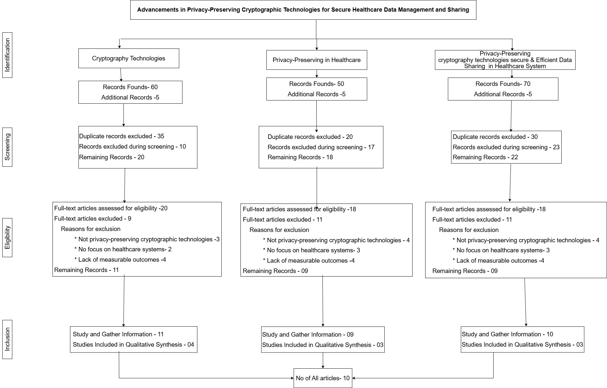

**Results**

The review of privacy-preserving cryptographic technologies reveals significant advancements in safeguarding healthcare data. Symmetric and asymmetric encryption methods are widely used to ensure the confidentiality and integrity of data during transmission and storage. Homomorphic encryption (HE) demonstrates notable potential by allowing computations on encrypted data without compromising patient privacy. This capability addresses a critical gap in traditional encryption techniques that require decryption for processing. Proxy re-encryption (PRE) enhances secure data sharing by enabling re-encrypted data to be accessed by multiple authorized parties without revealing the original encryption key. Furthermore, blockchain technology offers a decentralized and tamper-proof framework for managing healthcare data sharing across stakeholders, improving trust and auditability. These technologies collectively mitigate risks associated with data re-identification, cyber-attacks, and regulatory compliance challenges, providing a robust foundation for secure healthcare data management. However, challenges remain in achieving interoperability across healthcare systems and managing the computational complexity of advanced encryption methods.

**Conclusion and Discussion**

**Summary of the Above:** This paper reviewed privacy-preserving cryptographic technologies essential for securing healthcare data. Symmetric and asymmetric encryption methods ensure data confidentiality and integrity during transmission and storage. Advanced technologies such as homomorphic encryption (HE) allow secure computations on encrypted data, and proxy re-encryption (PRE) facilitates secure data sharing between institutions without key exposure. Blockchain technology enhances data security with decentralized and tamper-proof data-sharing frameworks. While these technologies address risks like data re-identification, cyber-attacks, and regulatory compliance challenges, issues such as interoperability and computational complexity persist.

**Future Works**

1. **Development of Quantum-Resistant Algorithms**: Focus on creating cryptographic solutions resilient to quantum computing threats.
2. **Scalable Homomorphic Encryption**: Optimize HE for large healthcare datasets to make it more practical for real-world applications.
3. **Interoperability Frameworks**: Develop standardized frameworks for seamless data exchange between disparate healthcare systems.
4. **Lightweight Cryptography**: Design resource-efficient cryptographic methods suitable for small and rural healthcare environments.
5. **AI Integration**: Investigate the integration of AI with cryptographic systems for dynamic threat detection and key management.

**Limitations**

1. **Computational Complexity**: Techniques like HE and blockchain demand significant computational resources, which can limit scalability.
2. **Interoperability Challenges**: Lack of standardized protocols for data exchange across healthcare systems hinders adoption.
3. **Regulatory Compliance**: Ensuring that cryptographic solutions comply with diverse regulations like HIPAA and GDPR is complex.
4. **Adoption Barriers**: High implementation costs and the need for specialized expertise limit widespread deployment, especially in smaller healthcare systems.

**Own idea about the Research:** Integrating cryptographic technologies with artificial intelligence (AI) could revolutionize healthcare data security. AI can enable real-time threat detection, adaptive cryptographic key management, and predictive analysis of vulnerabilities. Moreover, the combination of blockchain and federated learning can provide a decentralized, privacy-preserving approach to healthcare data sharing and AI model training. Finally, fostering global collaboration between governments, healthcare organizations, and technology providers will be crucial to developing scalable, secure, and universally applicable solutions.

**References**

1. Mitali, Vijay Kumar, and Arvind Sharma. “A Survey on Various Cryptography Techniques.” (August 2014), pp. 308-312.
2. A. Joseph Amalraj and Dr. J. John Raybin Jose. “A Survey Paper On Cryptography Techniques.” (August 2016), pp. 55-59.
3. Muharrem Tuncay Gençoğlu. “Importance Of Cryptography In Information Security.” (February 2019), pp. 65-68.
4. Shivani Sharma and Yash Gupta. “Study on Cryptography and Techniques.” (February 2017), pp. 249-252.
5. Kah Meng Chong. “Privacy-Preserving Healthcare Informatics: A Review.” Department of Mathematical and Actuarial Sciences, Universiti Tunku Abdul Rahman (UTAR).
6. Isabella Silva, Manuel Soto. “Privacy-Preserving Data Sharing in Healthcare: An In-Depth Analysis of Big Data Solutions and Regulatory Compliance.”
7. Hao Jin, Yan Luo, Peilong Li, and Jomol Mathew. “A Review of Secure and Privacy-Preserving Medical Data Sharing.” University of Massachusetts.
8. Linzhi Jiang et al. “Towards Practical Privacy-Preserving Processing Over Encrypted Data in IoT: An Assistive Healthcare Use Case.” IEEE.
9. Hao Jin, Yan Luo, Peilong Li, and Jomol Mathew. “A Review of Secure and Privacy-Preserving Medical Data Sharing.”
10. Saber Mhiri, Alfonso Egio, Maxime Compastié, and Pablo Cosio Molleda. “Proxy Re-Encryption for Enhanced Data Security in Healthcare: A Practical Implementation.”